CSPROJ and SOFTDEV doc.

6. Rationale of the Project  
 a. The current process of the flow  
 - 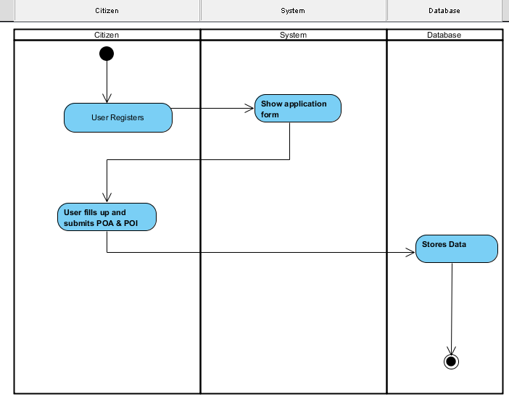  
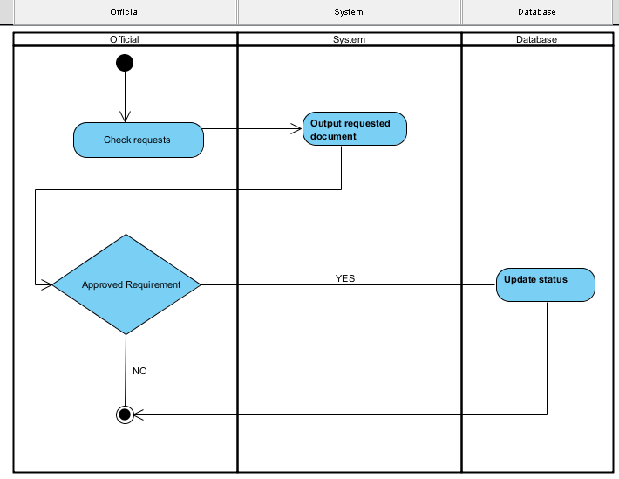  
 b. User Information Needs  
 - The user information needs registering information to the system, softcopies of Proof of Identity or Address. Examples are Meralco Bill, Maynilad Bill or Valid ID as long as there is a legit address of the citizen.   
 c. How the Information is being processed  
 - The information is processed by adding information of the citizen in the system and also the citizen can update his / her profile or make changes. The system displays the update information of the citizen.

C. System Features and Function  
1. Software Environment  
 a. Programming Languages  
 - The system make use of the HTML and CSS for the interface and design of the system and for the main function and connecting database it used PHP and JavaScript.  
 b. Specific Software  
 - In order for the system to create, it uses a COBALT framework, it’s the code generator used to create most function of the system and also creates the database. We used Sublime and Notepad++ for the text editor. As for the localhost of the system it uses XAMPP and WAMP for the PHPMyAdmin and also a web browser for the user interface. The XAMPP is also used for the connection for the mobile in order for the system will be resized in the mobile (it’s compatible in any mobile device). In editing our photos in contact and about page, we used Adobe Photoshop CS6.   
 c. Web Server Application  
 - The system used WampServer 2.5 (MySQL and PHP) it is a web development platform   
 used to create dynamic web applications with MySQL and PHP.  
 d. Operating System  
 - The barangay system is compatible to any operating system like Windows, Linux and Macintosh based on the fact that the system can run to any web browser.

e. Other Software  
 -

2. Hardware Environment  
 - The recommended minimum requirements are 256MB of RAM for a single-computer website and 85MB of storage with as little as 48MB of RAM.

3. Networking and Security  
 a. Security  
 b. Server  
 - The system used WampServer 2.5 (MySQL and PHP) it is a web development platform   
 used to create dynamic web applications with MySQL and PHP.  
4. Application System Modules

A. Citizen Registers  
 - The citizen must first register to the system in order to use the main function of the system like requesting basic barangay documents.  
b. Request Document  
 - The citizen can able to request basic barangay documents like barangay id, barangay clearance, and business permit and etc.   
c. Update Bulletin  
 - The system has a bulletin about the news, updates, events and happening in the barangay.

II. System Diagrams and Screenshots  
a. Data Flow Diagrams  
 1. Context Leve Data Flow Diagram  
 2. Level 0 Data Flow Diagram  
b. UML Diagrams  
 **Class Diagram** 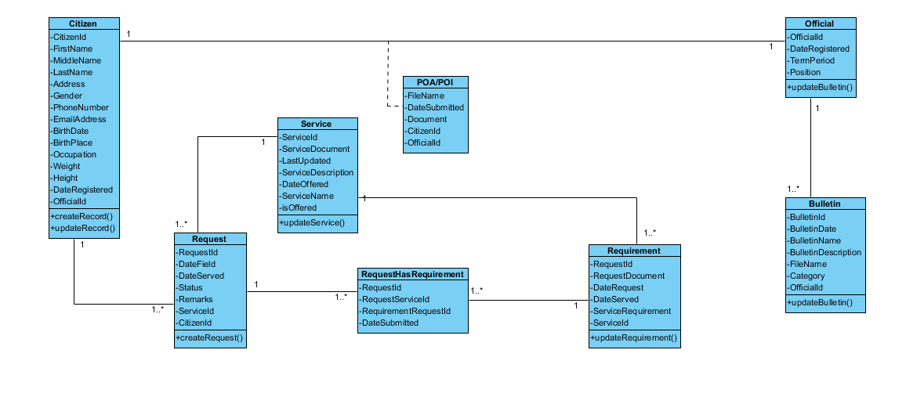

**Use Case Diagram**  
 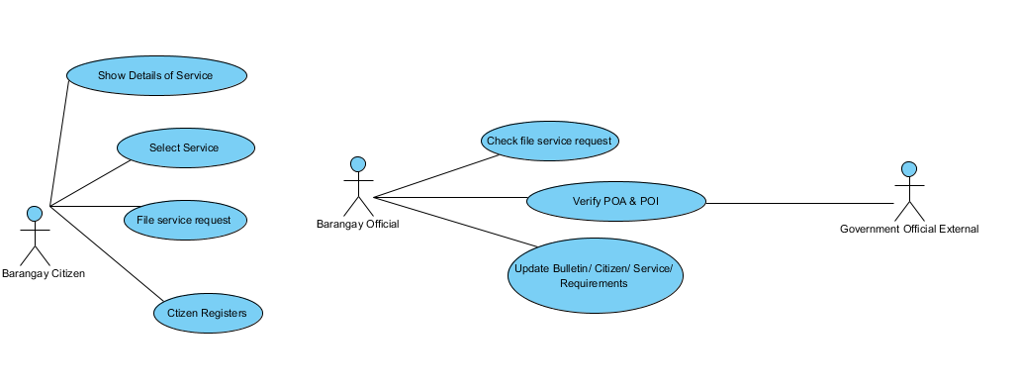  
 **Activity Diagram**  
 Select Service  
 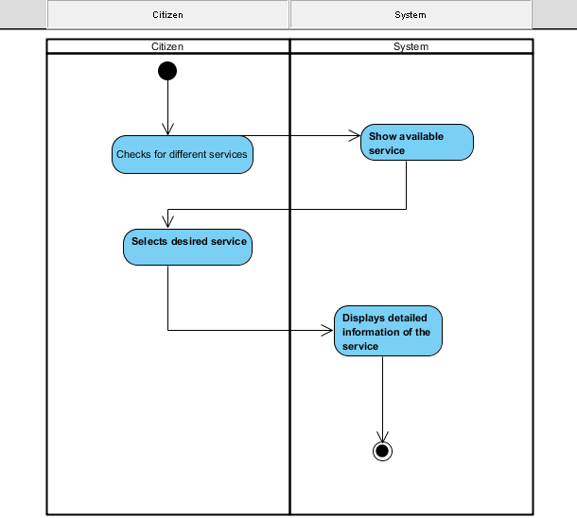

File Service Request  
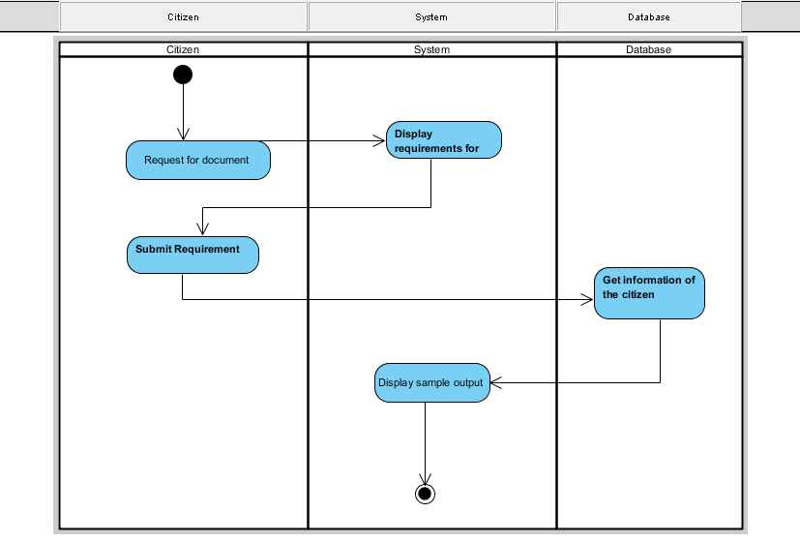

Citizens Register



Check File Service Request



Verify Proof of Identity / Address (POI / POA)

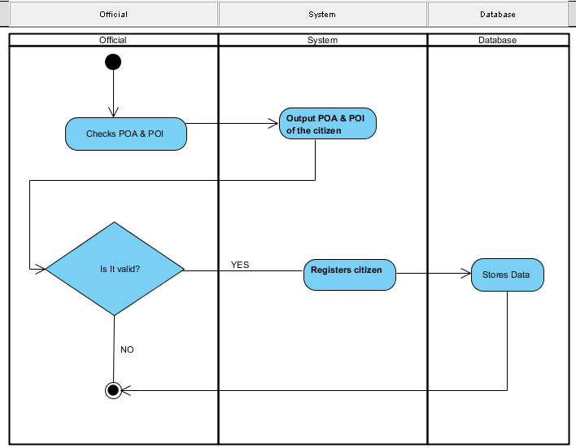

**Sequence Diagram**

Select Service

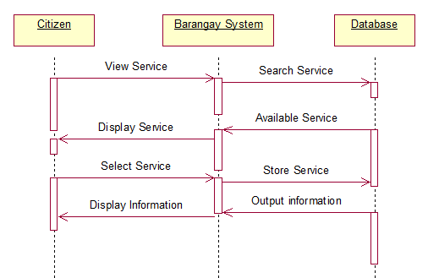

File Service Request

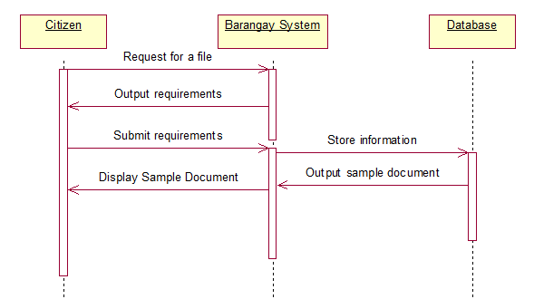

Citizen Registers

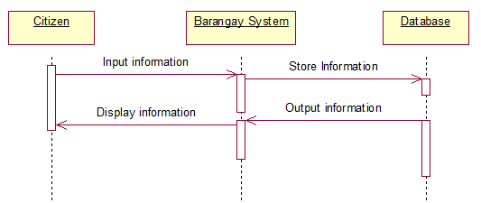

Check File Service Request

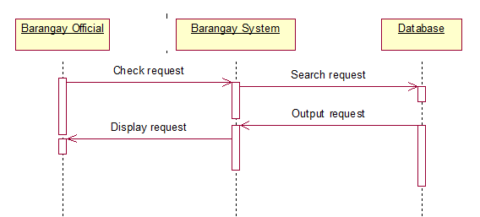

Verify Proof of Identity / Address (POI / POA)

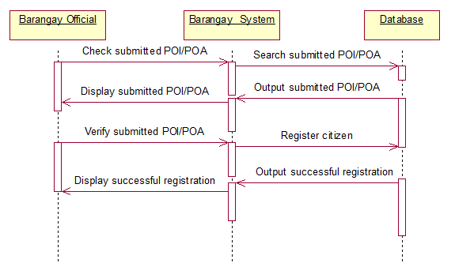

Update Bulletin

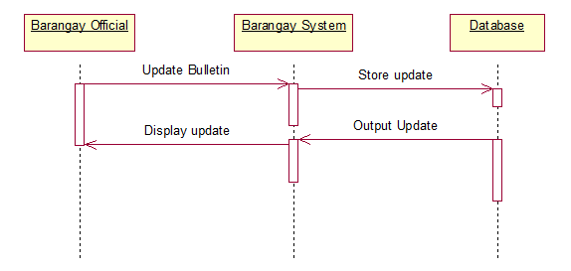

**Collaboration Diagram**

Select Service

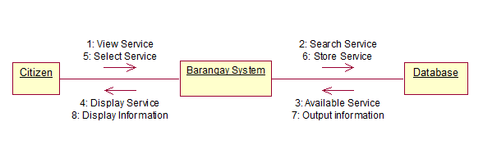

File Service Request

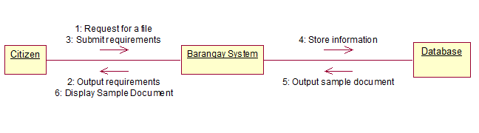

Citizen Registers

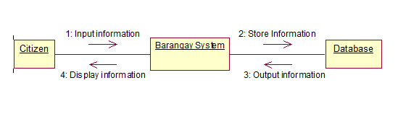

Check File Service Request

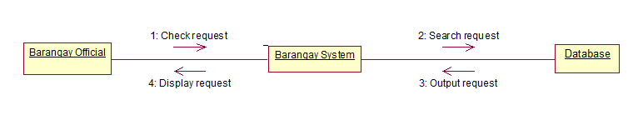

Verify Proof of Identity / Address (POI / POA)

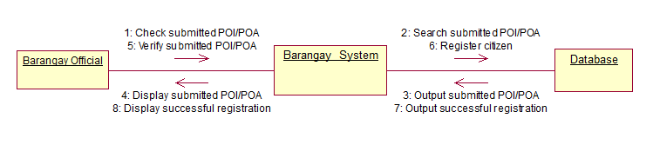

Update Bulletin

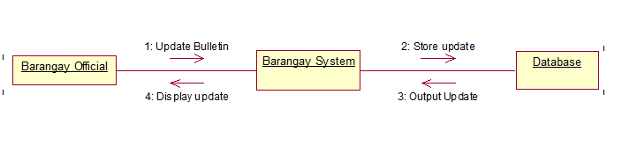

**Component Diagram**

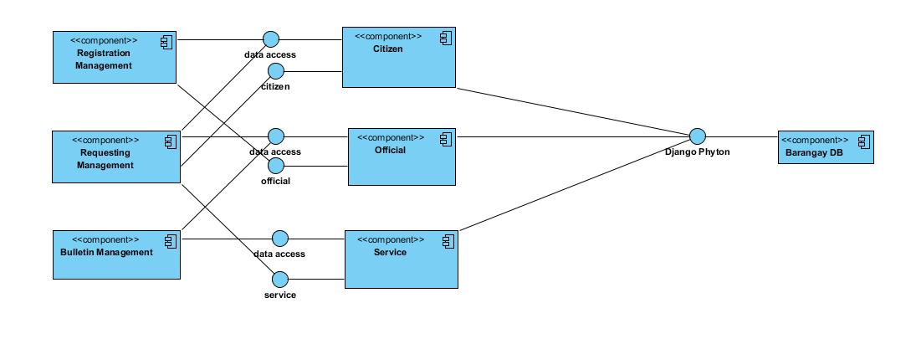

**Composite Diagram**

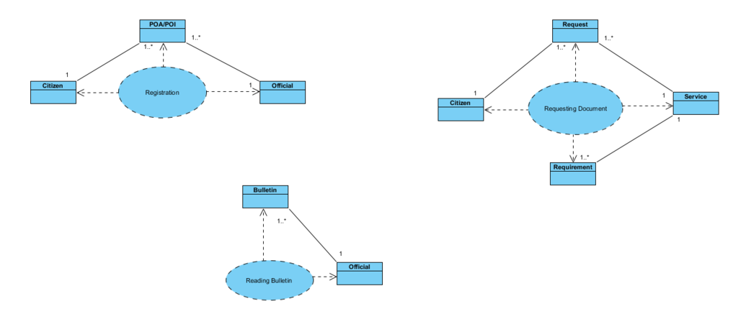

**Deployment Diagram**

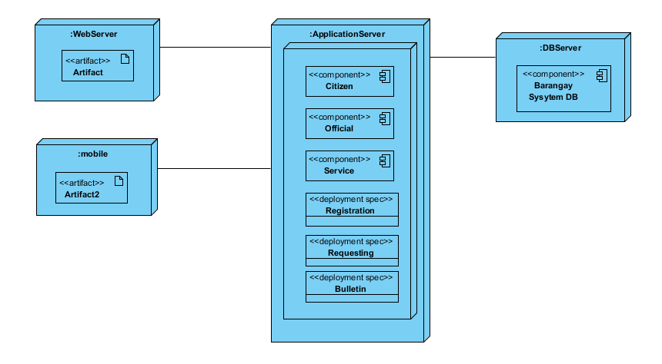

**Interaction Diagram**

Citizen Registers

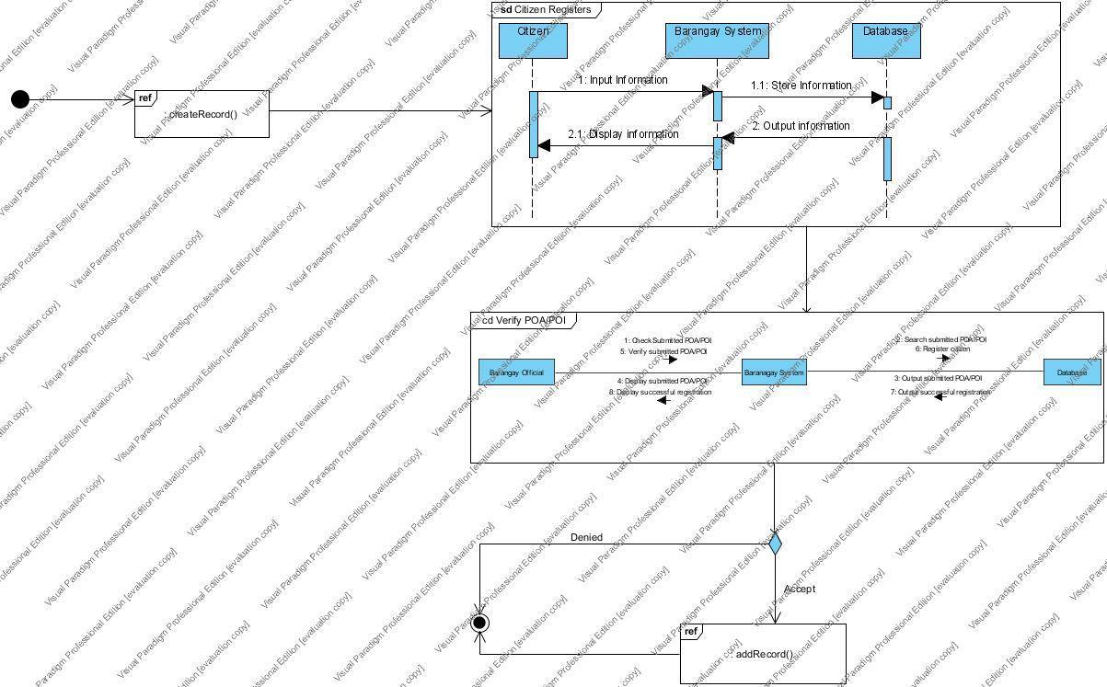

Request Document

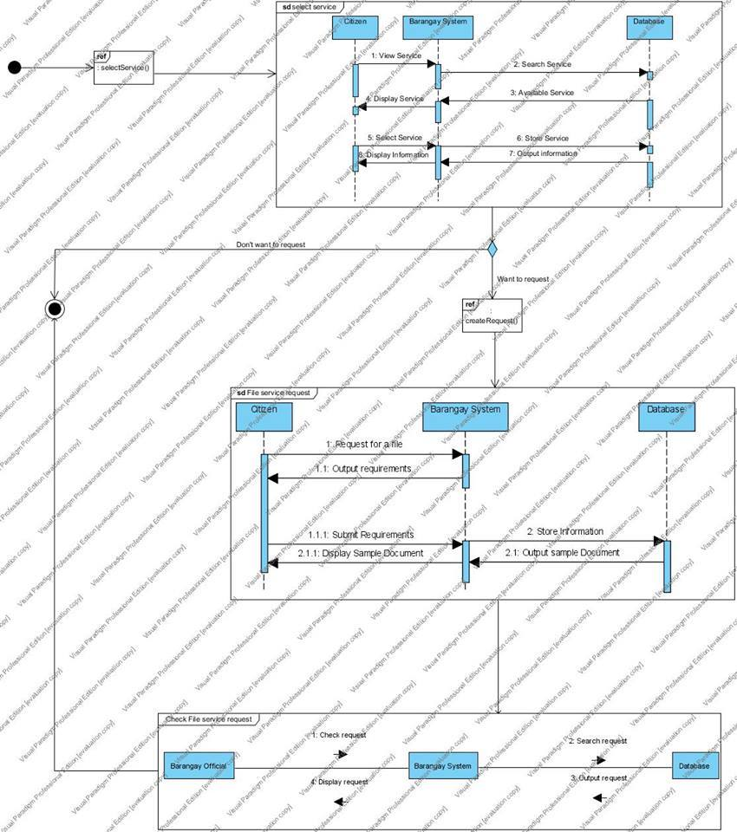

Update Bulletin

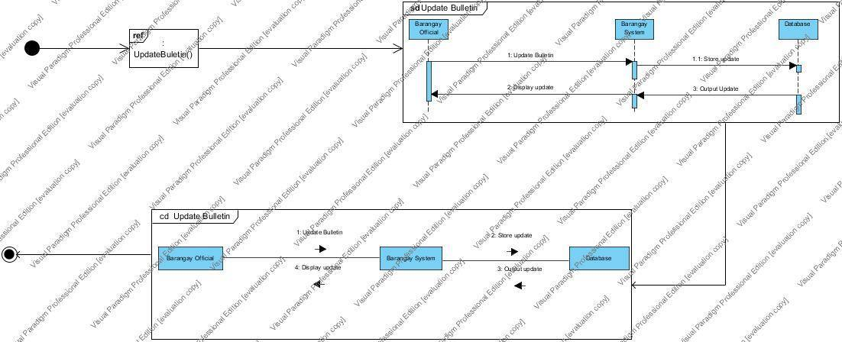

**Package Diagram**

Citizen Registers

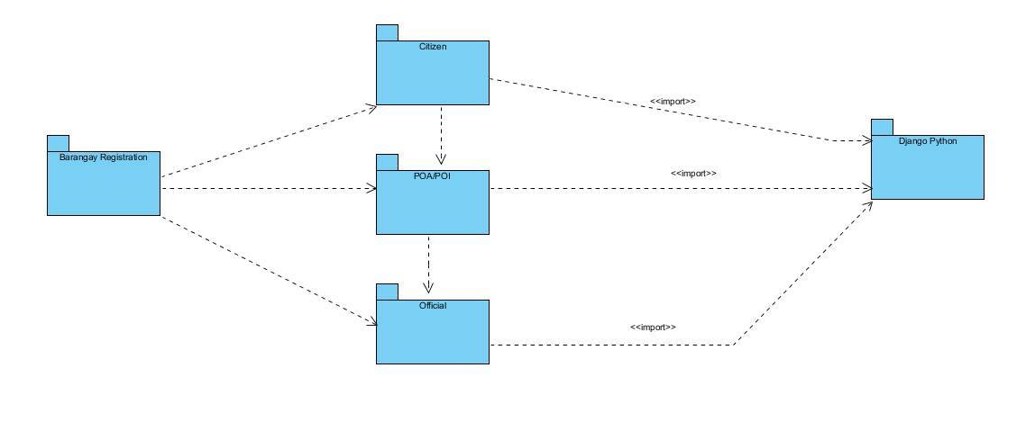

Request Document

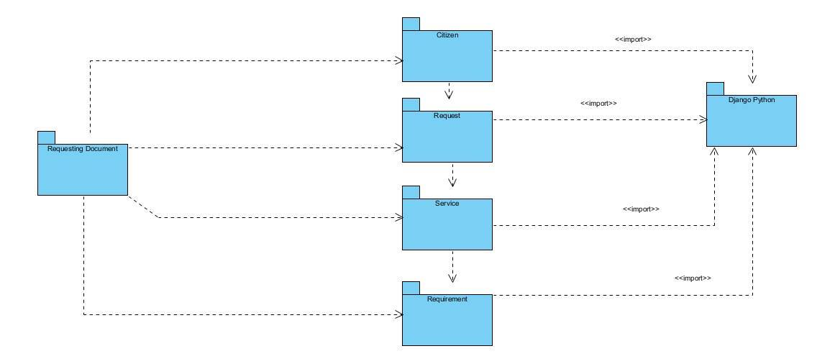

Update Bulletin

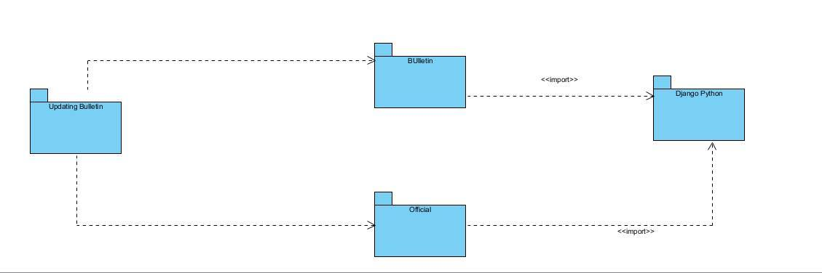

**Object Diagram**

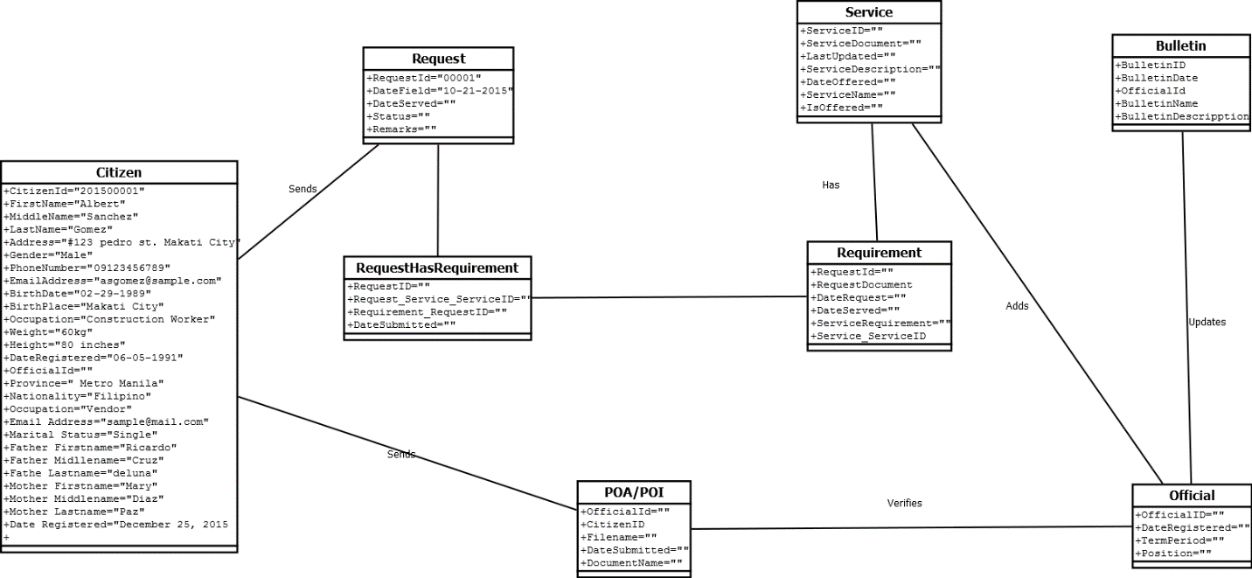

**State Machine Diagram**

Citizen Register

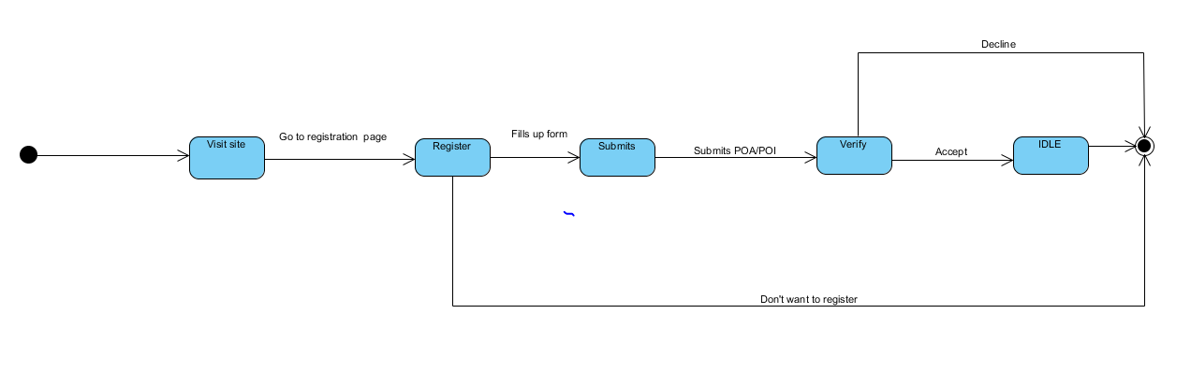

Request Document

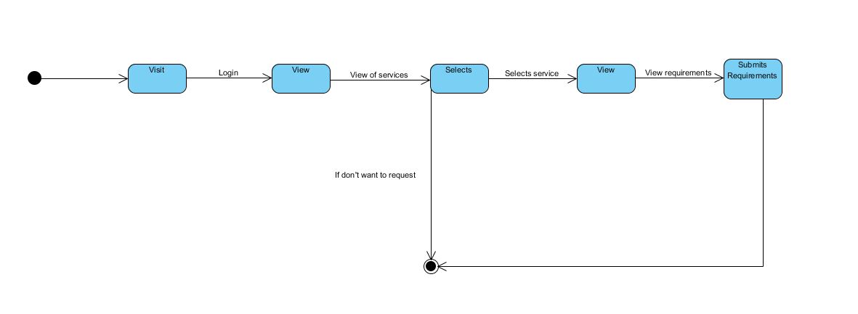

**Timing Diagram**

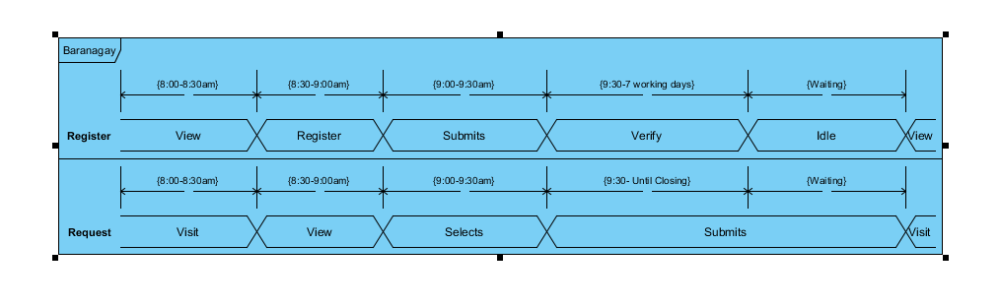

c. Entity Relationship Diagram  
d. Data Dictionary  
e. Screenshots  
f. Lesson Learn

III. Appendices